**TEST**

1. Create a bar chart to display to show top 5 customer name sale wise

Ans:

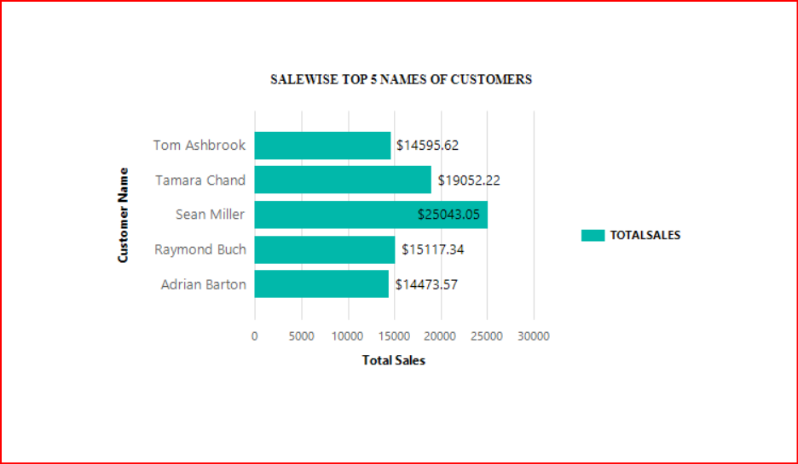

1. Create a pie chart that show subcategory wise total orders placed.

Ans:

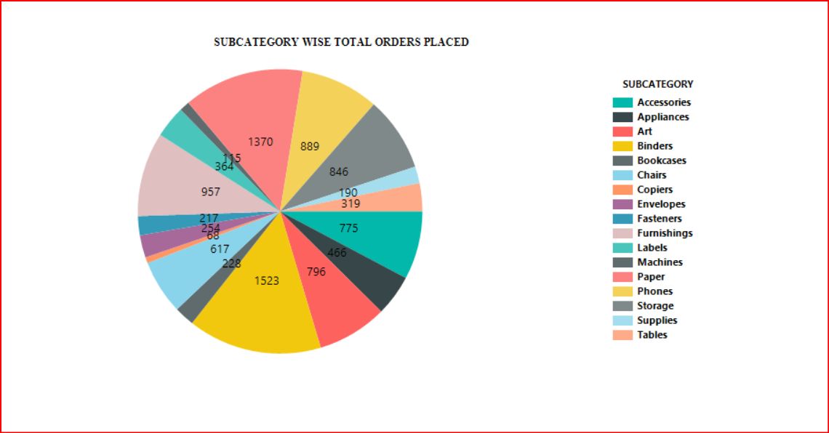

1. Create a drill down report

Ans:

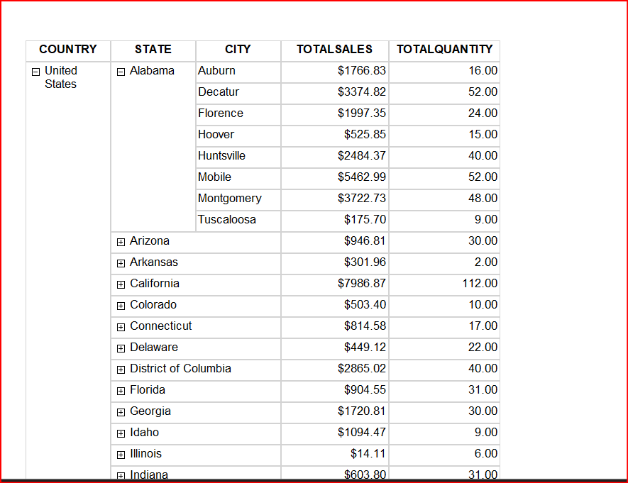

1. Create a SSRS report for display page level filter

Ans:

